Web Programming Lab - Week 5

Name: Srihari Srinivasan

Date: 04/02/2025

Section: C Roll No: 40

Registration Number: 220905326

1. Create a web form which allows the teacher to enter the student details like name, date

of birth, address, contact number, email id and marks of English, Physics and

Chemistry. After filling all the information and on clicking submit button, details

should be added to a textarea displayed on the same page. Display the total percentage

of marks obtained in a label.

**base.html:**

<!DOCTYPE html>

<html>

<head>

<meta charset="utf-8" />

<link

href="https://cdn.jsdelivr.net/npm/bootstrap@5.3.3/dist/css/bootstrap.min.css"

rel="stylesheet"

/>

<title>Enter Student Details</title>

<script src="https://code.jquery.com/jquery-3.6.0.min.js"></script>

</head>

<body class="bg-light">

<div class="container mt-5">

<h1 class="text-center mb-4">Student Details</h1>

<form id="student-form">

<div class="mb-3">

<label class="form-label">Enter your name:</label>

<input id="name" type="text" class="form-control" />

</div>

<div class="mb-3">

<label class="form-label">Enter your DOB:</label>

<input id="dob" type="text" class="form-control" />

</div>

<div class="mb-3">

<label class="form-label">Enter your number:</label>

<input id="number" type="text" class="form-control" />

</div>

<div class="mb-3">

<label class="form-label">English Marks:</label>

<input id="eng_marks" type="text" class="form-control" />

</div>

<div class="mb-3">

<label class="form-label">Physics Marks:</label>

<input id="phy_marks" type="text" class="form-control" />

</div>

<div class="mb-3">

<label class="form-label">Chemistry Marks:</label>

<input id="chem_marks" type="text" class="form-control" />

</div>

<div class="text-center mt-4">

<button type="submit" class="btn btn-primary">

Submit

</button>

</div>

</form>

<div class="mt-4 text-center">

<h4 id="result" class="text-success"></h4>

</div>

</div>

<script>

$(document).ready(function () {

$("#student-form").submit(function (event) {

event.preventDefault();

var eng = parseFloat($("#eng_marks").val()) || 0;

var phy = parseFloat($("#phy_marks").val()) || 0;

var chem = parseFloat($("#chem_marks").val()) || 0;

var totalMarks = eng + phy + chem;

var percentage = (totalMarks / 300) * 100;

$("#result").text(

"Final Percentage: " + percentage.toFixed(2) + "%"

);

});

});

</script>

</body>

</html>

**Output:**

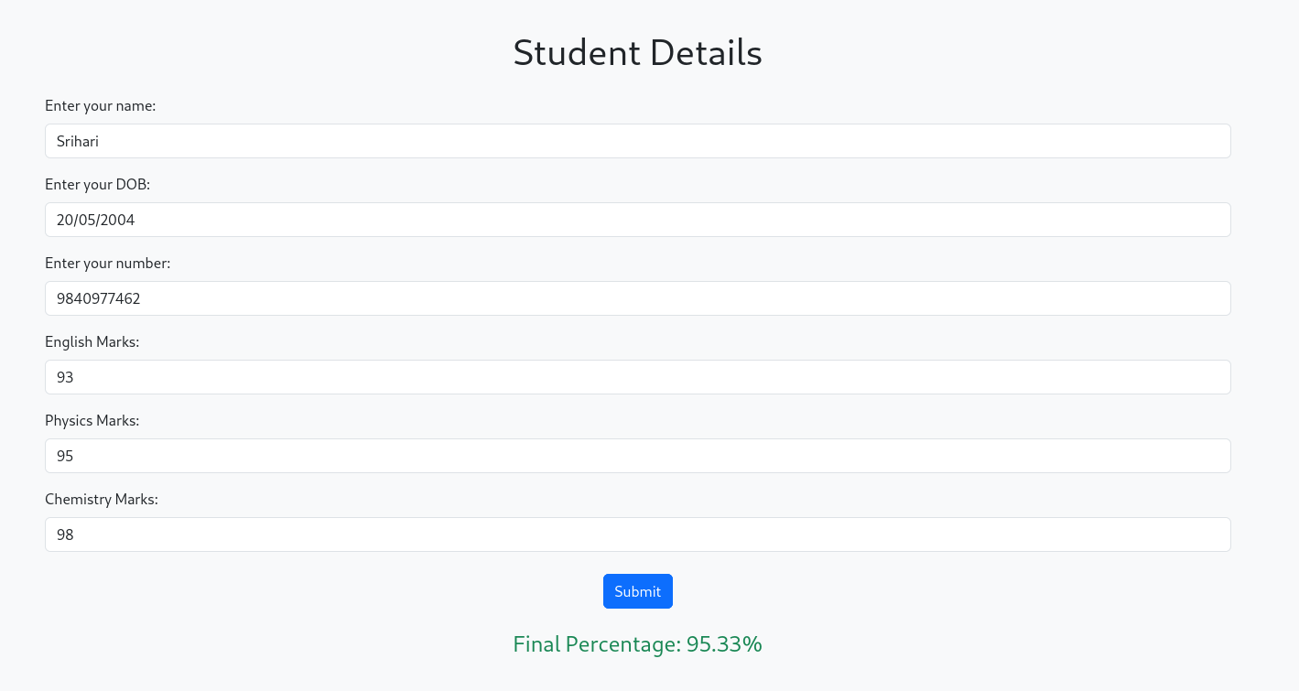

1. Create a web form with employee ids in dropdown list. Use a textbox for accepting date

of joining. Add a button named “Am I Eligible for Promotion”. On clicking the button,

if he has more than 5 years of experience, then display “YES” else “NO” in the label

Control.

**base.html:**

<!DOCTYPE html>

<html>

<head>

<meta charset="utf-8" />

<link

href="https://cdn.jsdelivr.net/npm/bootstrap@5.3.3/dist/css/bootstrap.min.css"

rel="stylesheet"

/>

<script src="https://code.jquery.com/jquery-3.6.0.min.js"></script>

<title>Employee Promotion Eligibility</title>

</head>

<body class="bg-light">

<div class="container mt-5">

<h1 class="text-center mb-4">Employee Promotion Eligibility</h1>

<div class="mb-3">

<label class="form-label">Select Employee ID:</label>

<select id="employee_id" class="form-control">

<option value="E101">E101</option>

<option value="E102">E102</option>

<option value="E103">E103</option>

<option value="E104">E104</option>

</select>

</div>

<div class="mb-3">

<label class="form-label">Date of Joining:</label>

<input type="date" id="doj" class="form-control" />

</div>

<div class="text-center mt-4">

<button id="check_eligibility" class="btn btn-primary">

Am I Eligible for Promotion?

</button>

</div>

<div class="mt-4 text-center">

<h4 id="result"></h4>

</div>

</div>

<script>

$(document).ready(function () {

$("#check_eligibility").click(function () {

var doj = $("#doj").val();

if (!doj) {

alert("Please select a valid Date of Joining.");

return;

}

var joiningDate = new Date(doj);

var currentDate = new Date();

var experience =

(currentDate - joiningDate) /

(1000 * 60 * 60 * 24 * 365);

var eligibility = experience > 5 ? "YES" : "NO";

$("#result").text("Eligible for Promotion: " + eligibility);

$("#result")

.removeClass("text-success text-danger")

.addClass(

eligibility === "YES"

? "text-success"

: "text-danger"

);

});

});

</script>

</body>

</html>

**Output:**

